**Basic Queries**

1. Creating database and using the database.

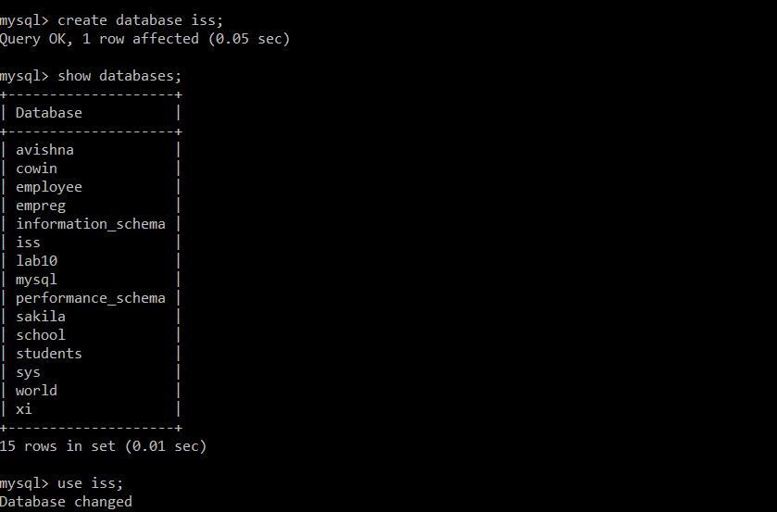

1. Creating a table named Interns with attributes.

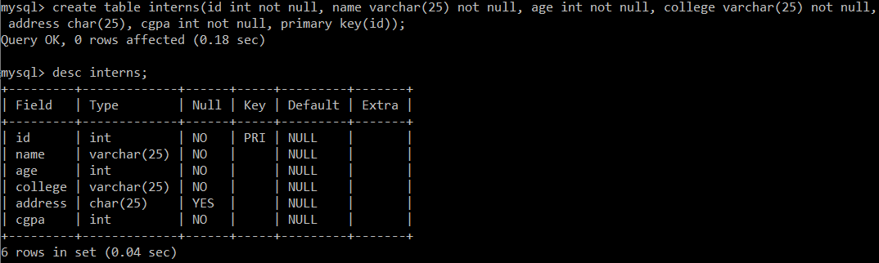

1. Inserting values into the table named ‘Interns’



1. Selecting all the values from the table to display.



1. Selecting the values with specific ‘where’ case.

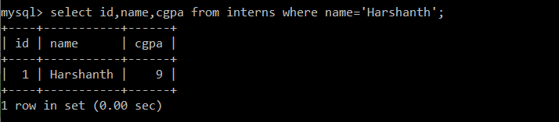

1. AND clause for selecting and displaying the values from table.

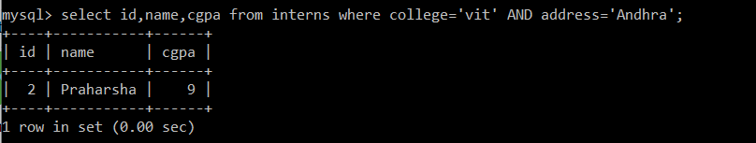

1. OR Clause for displaying details whether age is 20 or address is Chennai from table.

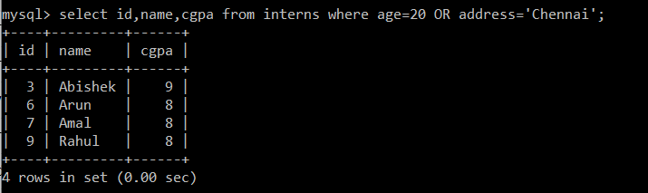

1. ORDER BY clause for displaying the values in respective order format.

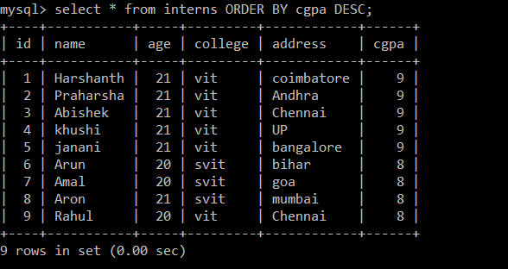

1. Update certain Column value for a specific person.

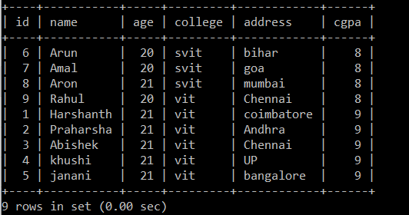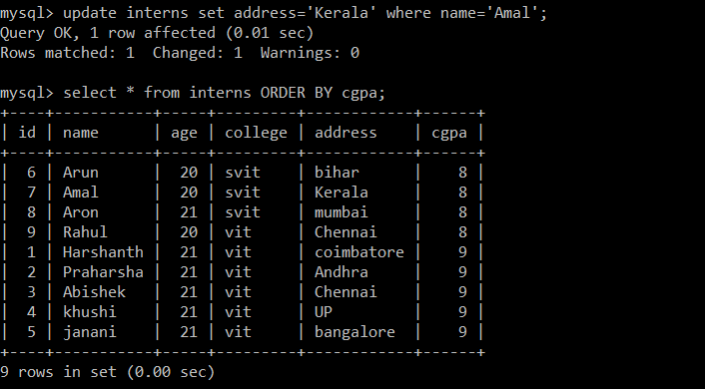

1. DELETE Clause for deleting the table or any specific row from table.

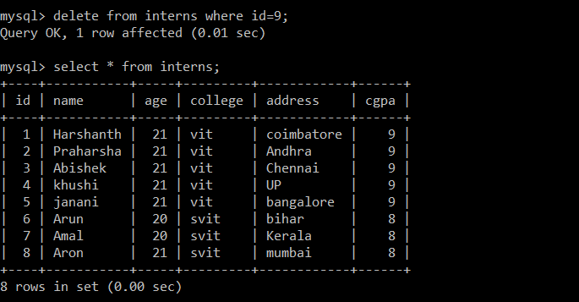

1. Select TOP clause, used to display top elements of the table.

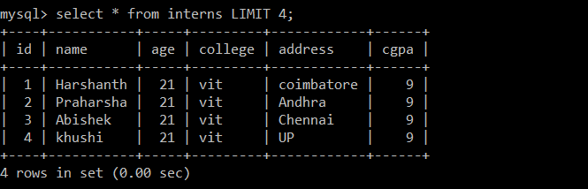

1. Like clause to display the values similar to conditions given.

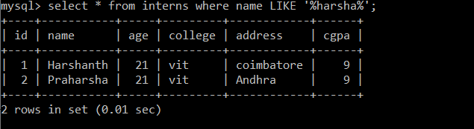

1. Wildcards using % and _ to select the values similar to the conditions.

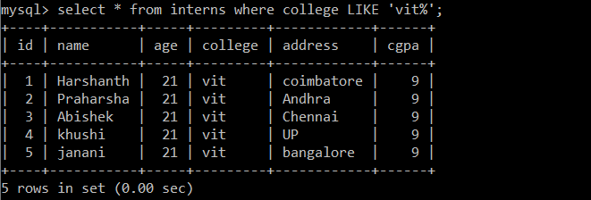

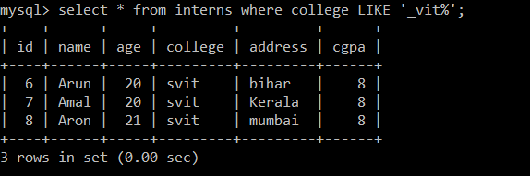

1. Selecting with Distinct clause for not displaying the duplicate values.

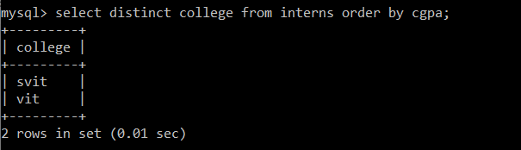

1. Primary Key is empid and when compared to table intern, empid id foreign key. Here the empid and name are set to be Not Null column values.

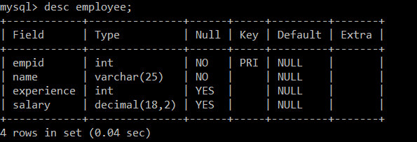

1. Alter

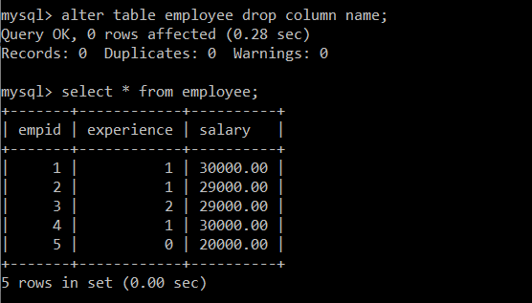

1. Joins the two tables ‘interns’ and ‘employee’ with primary key of interns(id) and foreign key (empid) and displayed the values from two tables into one.

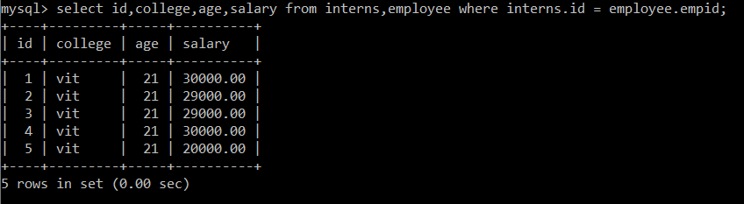

1. Inner join clause - returns rows when there is a match in both tables.

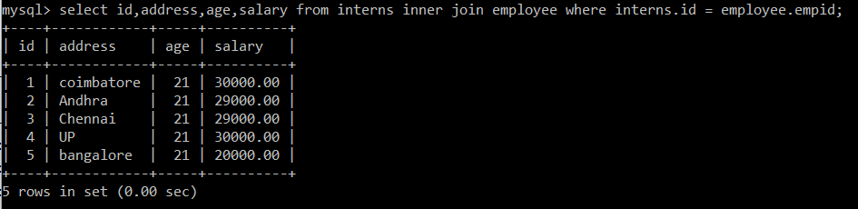

1. Right join - returns all rows from the right table, even if there are no matches in the left table

